TRAINING REPORT
CBA

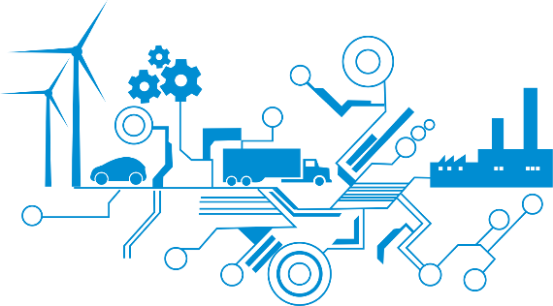

SUBMITTED BY: DEEPANSH MADAN

EMP ID:213458

Contents
1 TABLE OF FIGURES 3
2 Creation of Repository in GitHub 4
3 Cpp Check 5

TABLE OF FIGURES

Figure 1Creation of Github Repository 4

Creation of Repository in GitHub

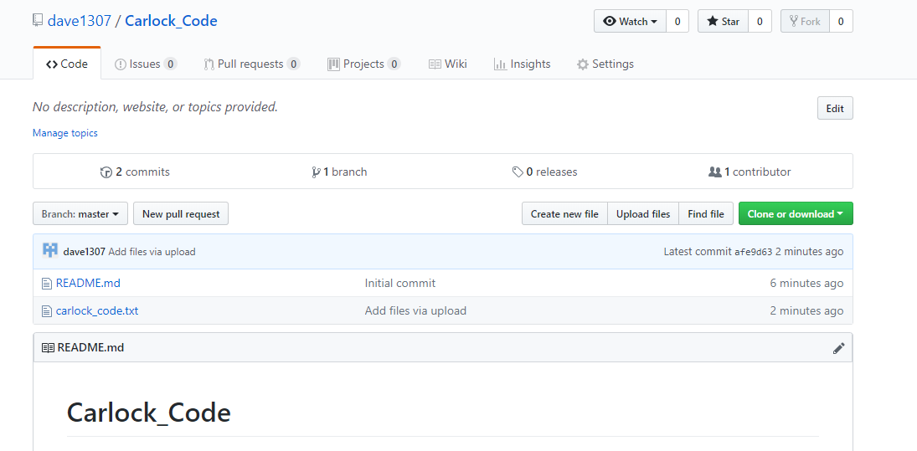
Figure 1Creation of Github Repository

Cpp Check

